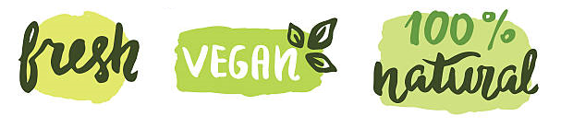

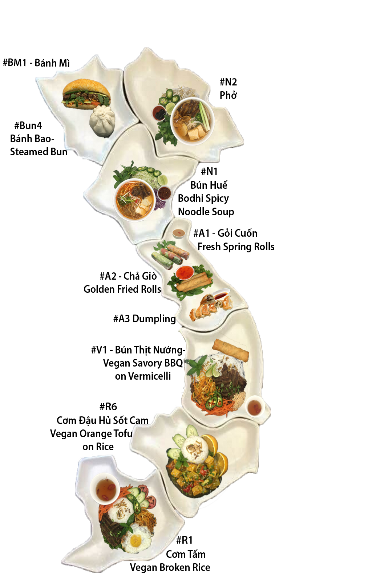

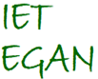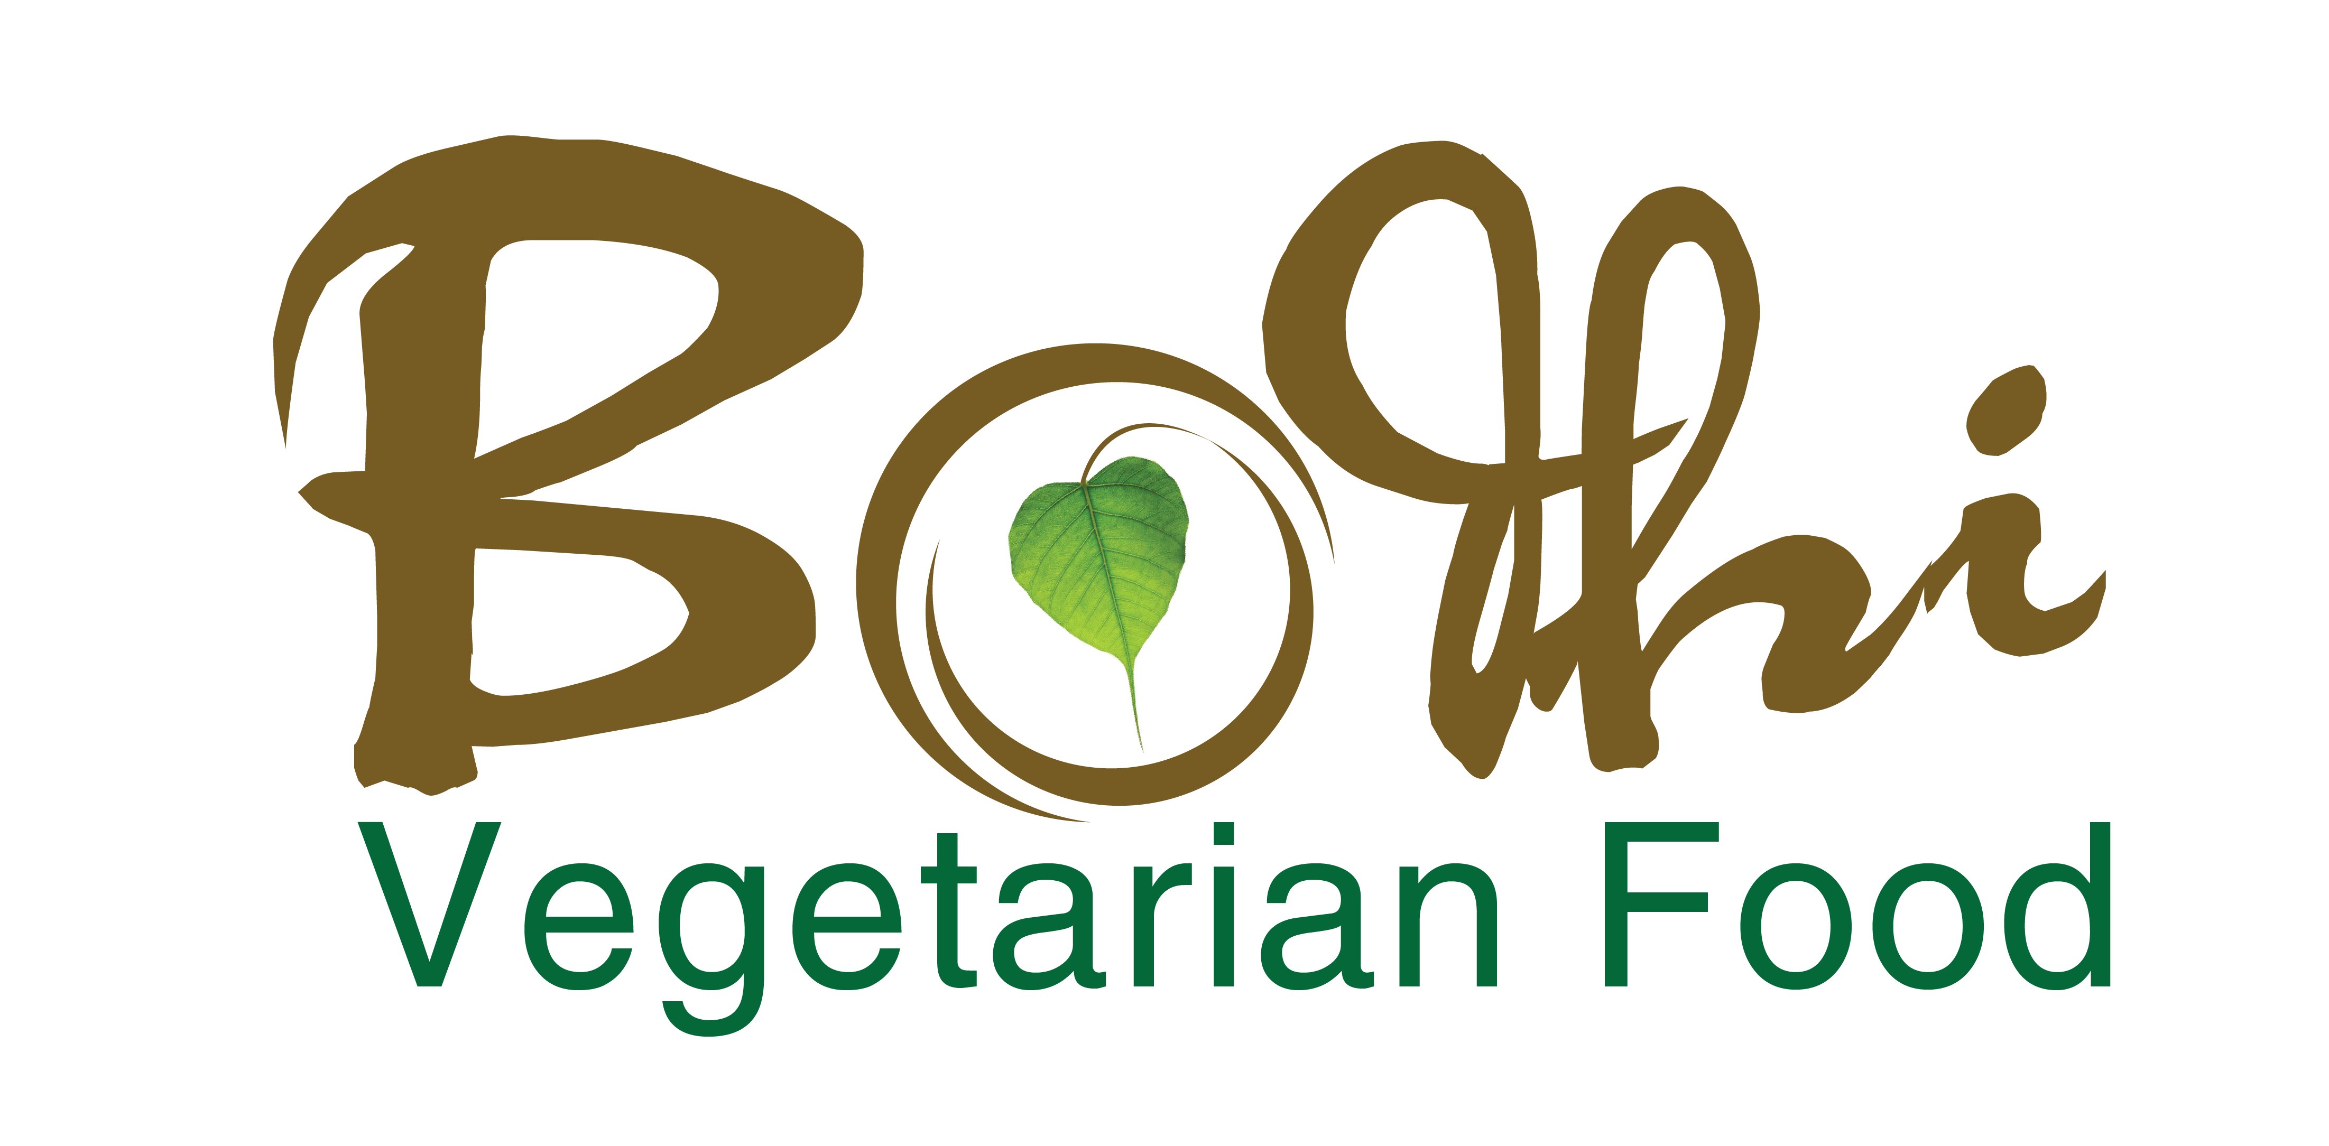

(512) 696-1807

www.bodhivietvegan.com

Mission

Peace begins on your plate. Our goal is to spread this message through tasty, homemade meat-free and meat-alternative Vietnamese cuisine. We are a group of local Buddhist nuns and volunteers who believe that wholesome vegan food is the key to a peaceful and healthy lifestyle. We seek to spread basic principles of wisdom and peace through fresh and affordable food.



Authentic

Vietnamese

Cuisine

Main Location

2301 West Parmer Lane

Austin, TX 78727

Tuesday-Friday: 9 AM - 4 PM

Saturday: 11 AM - 5 PM



Free Delivery (5 miles Radius)

* Lunch: 11 AM – 2 PM

Place Order 2 hours Before

* Dinner: 5 PM -7 PM

Place Order Before 3 PM



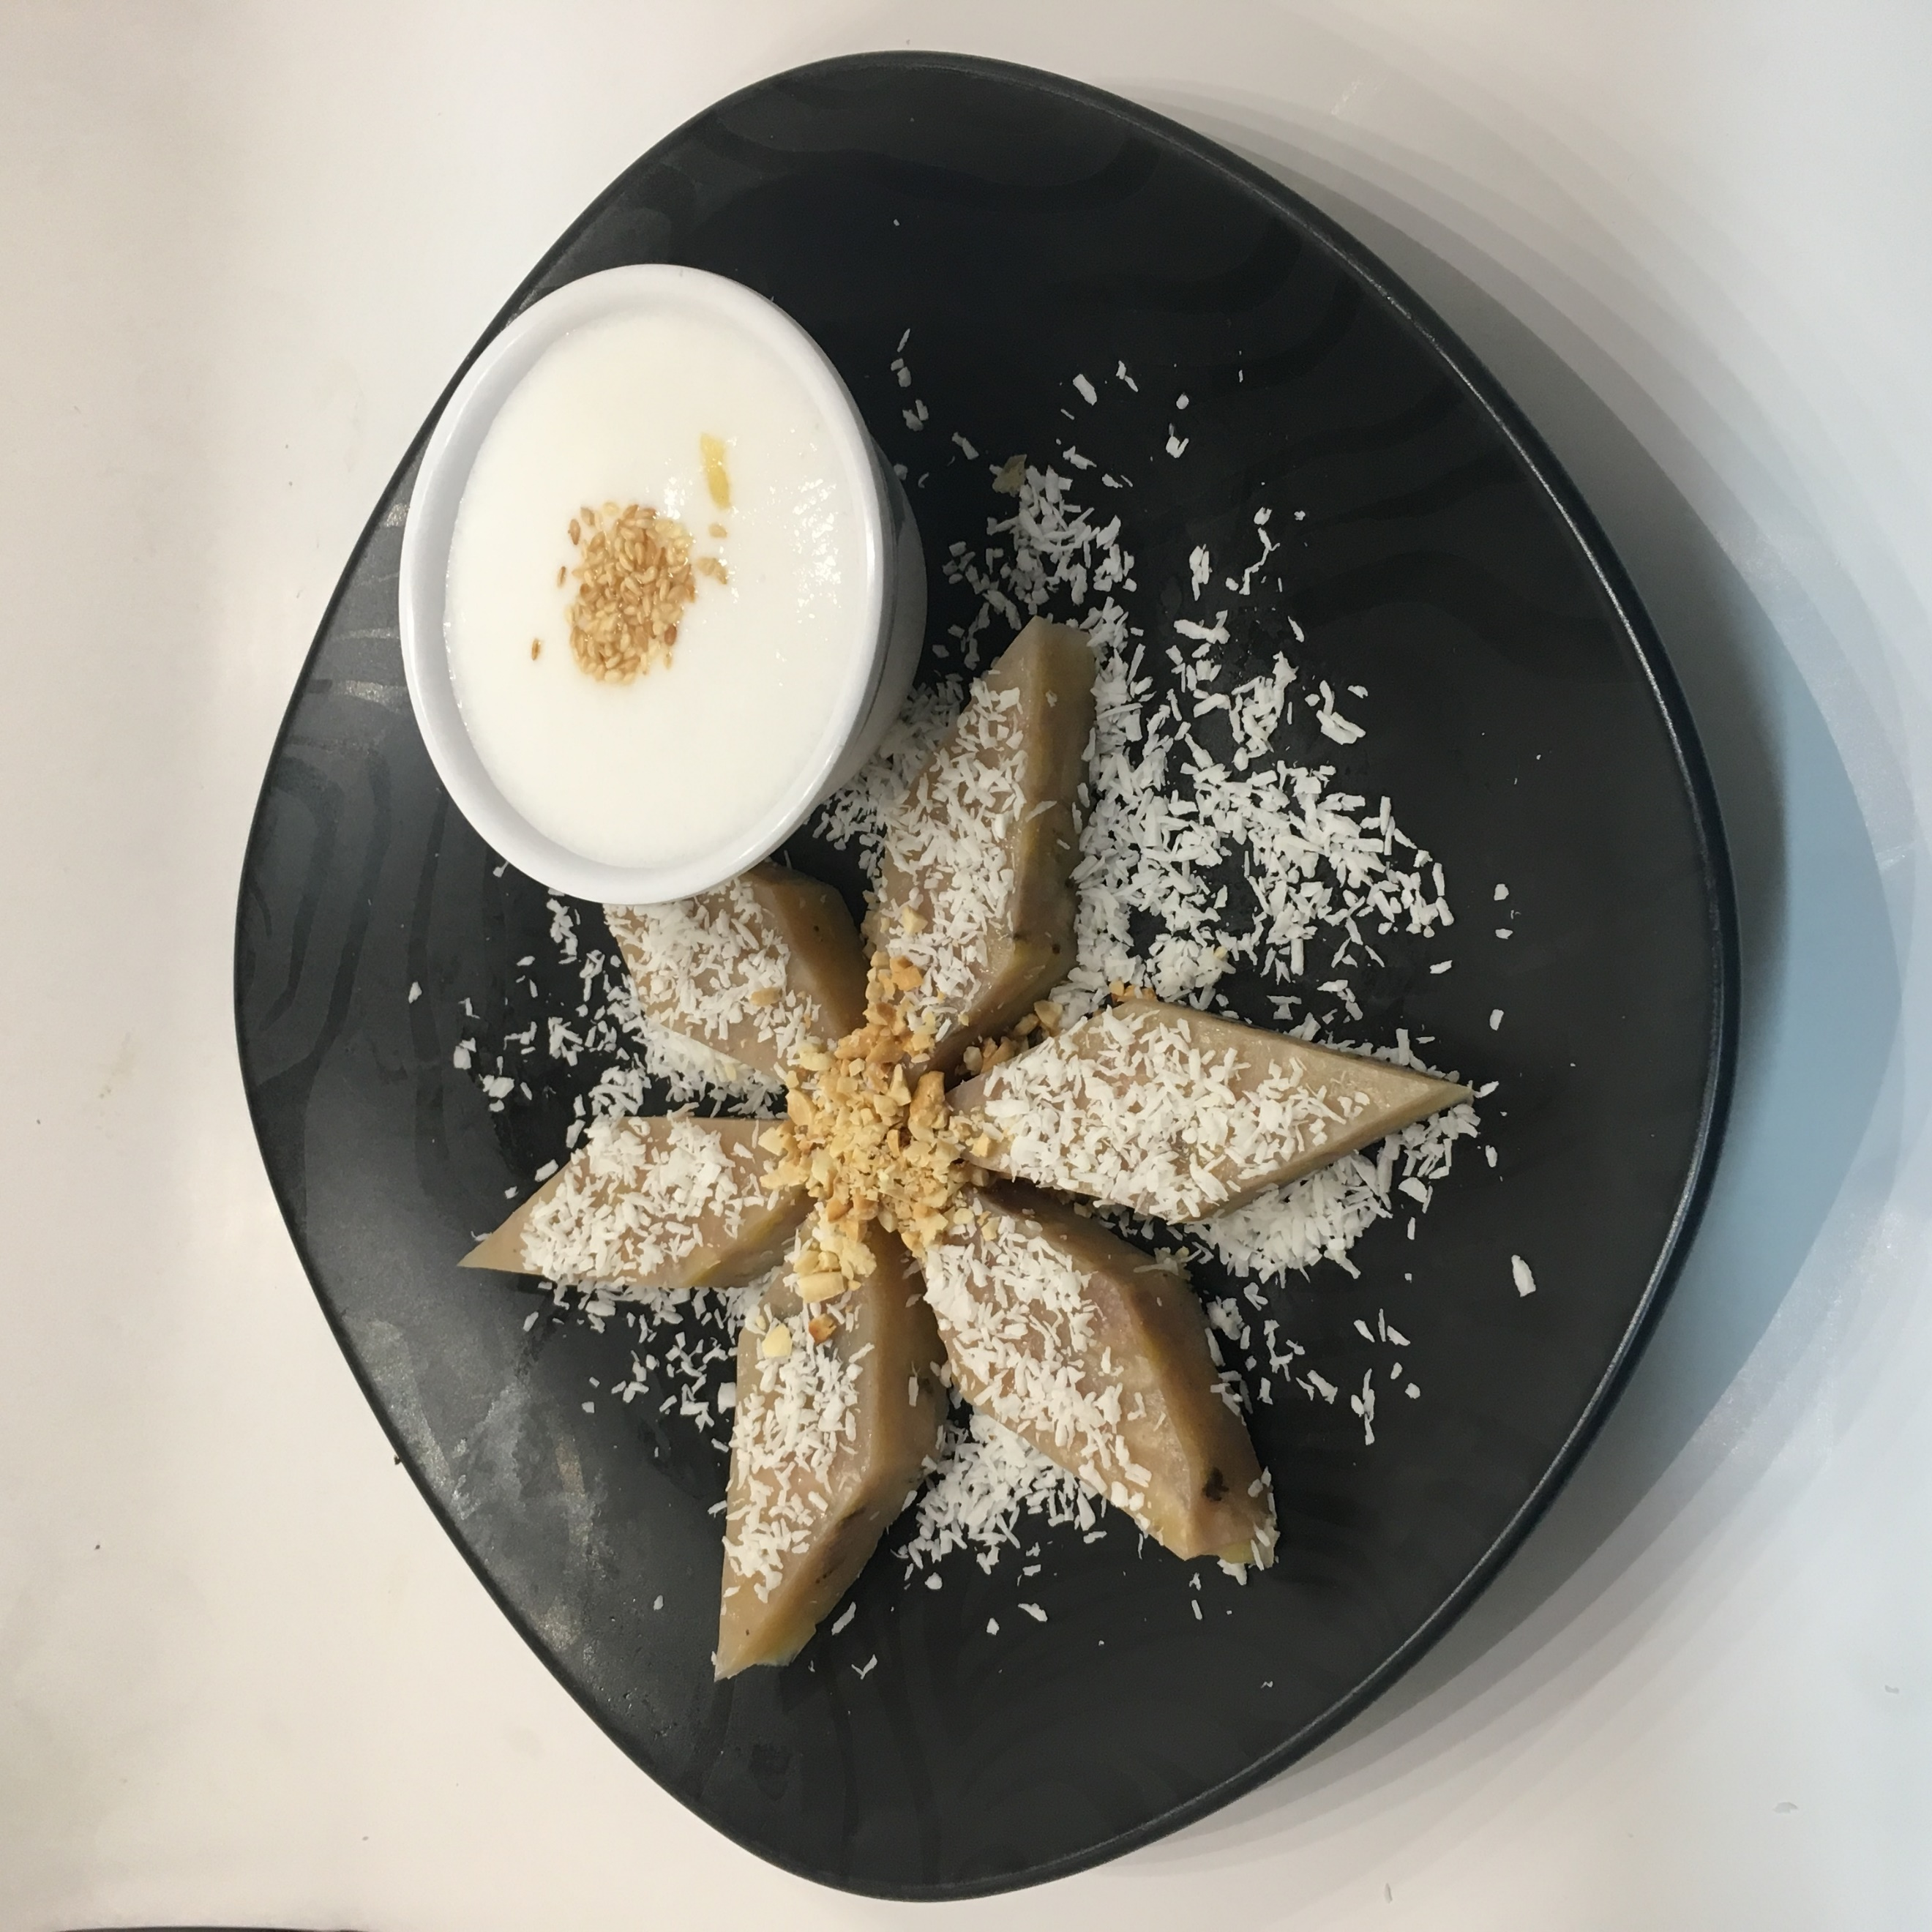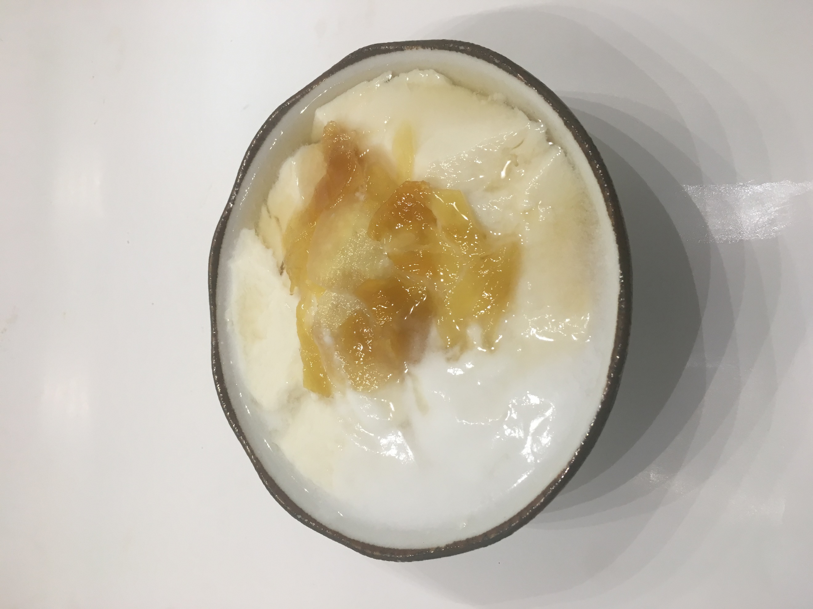

Noodle Soups **$6**

*White & purple cabbage, bean sprout, onion, cilantro, jalapeño, basil, and/or steamed vegetables*

•#N1 (Vegan Bodhi Spicy Noodle Soup - Bún Huế)

•#N2 (Vegan Signature Viet PHO - Phở Hà Nội)

#N3 (Vegan Fresh Homemade Viet Udon - Bánh Canh Tươi)

#N4 (Vegan Wonton Noodle Soup –

Hủ Tiếu Mì Wonton)

#N5 (Vegan Viet Spicy Tom-Yum Noodle Soup - Bún Măng Chua)

#N6 (Vegan Viet Tofu Noodle Soup - Bún Riêu)

•#D7 (Iced/hot Vegan Fresh Homemade Soy Milk -Sữa *Đậu* *Nành*)

•#D4 (Iced Vegan/Vegetarian Vietnamese *Coffee - Cafe Sữa Đá*)

•#D5 (Iced Vegan Green Milk Tea Boba –

[Trà](https://www.google.com/search?client=safari&rls=en&ei=DrBWWub3COLZgAb1mZ7gDQ&q=vietnamese+translation&oq=vietnamese+translation&gs_l=psy-ab.3...747382.749736.0.749943.22.9.0.0.0.0.0.0..0.0....0...1.1.64.psy-ab..22.0.0....0.b6vQmmGoNmE) Thái Boba)

•#D6 (Iced Vegan Tamarind, Roasted Peanuts, Sesame Seeds - Nước Đá Me)

•#D8 (Soda/Bottle Water)

Stir-Fry Noodles **$6**

*Fried tofu, vegan protein, mixed spring vegetables,*

*bean sprout, onion, cilantro, jalapeño*

#S1 (Vegan Yellow Noodle Stir-fried - Mì Xào)

#S2 (Vegan Rice Vermicelli Stir-fried - Bún Xào)

#S3 (Vegan Glass Noodle Stir-fried - Miến Xào)

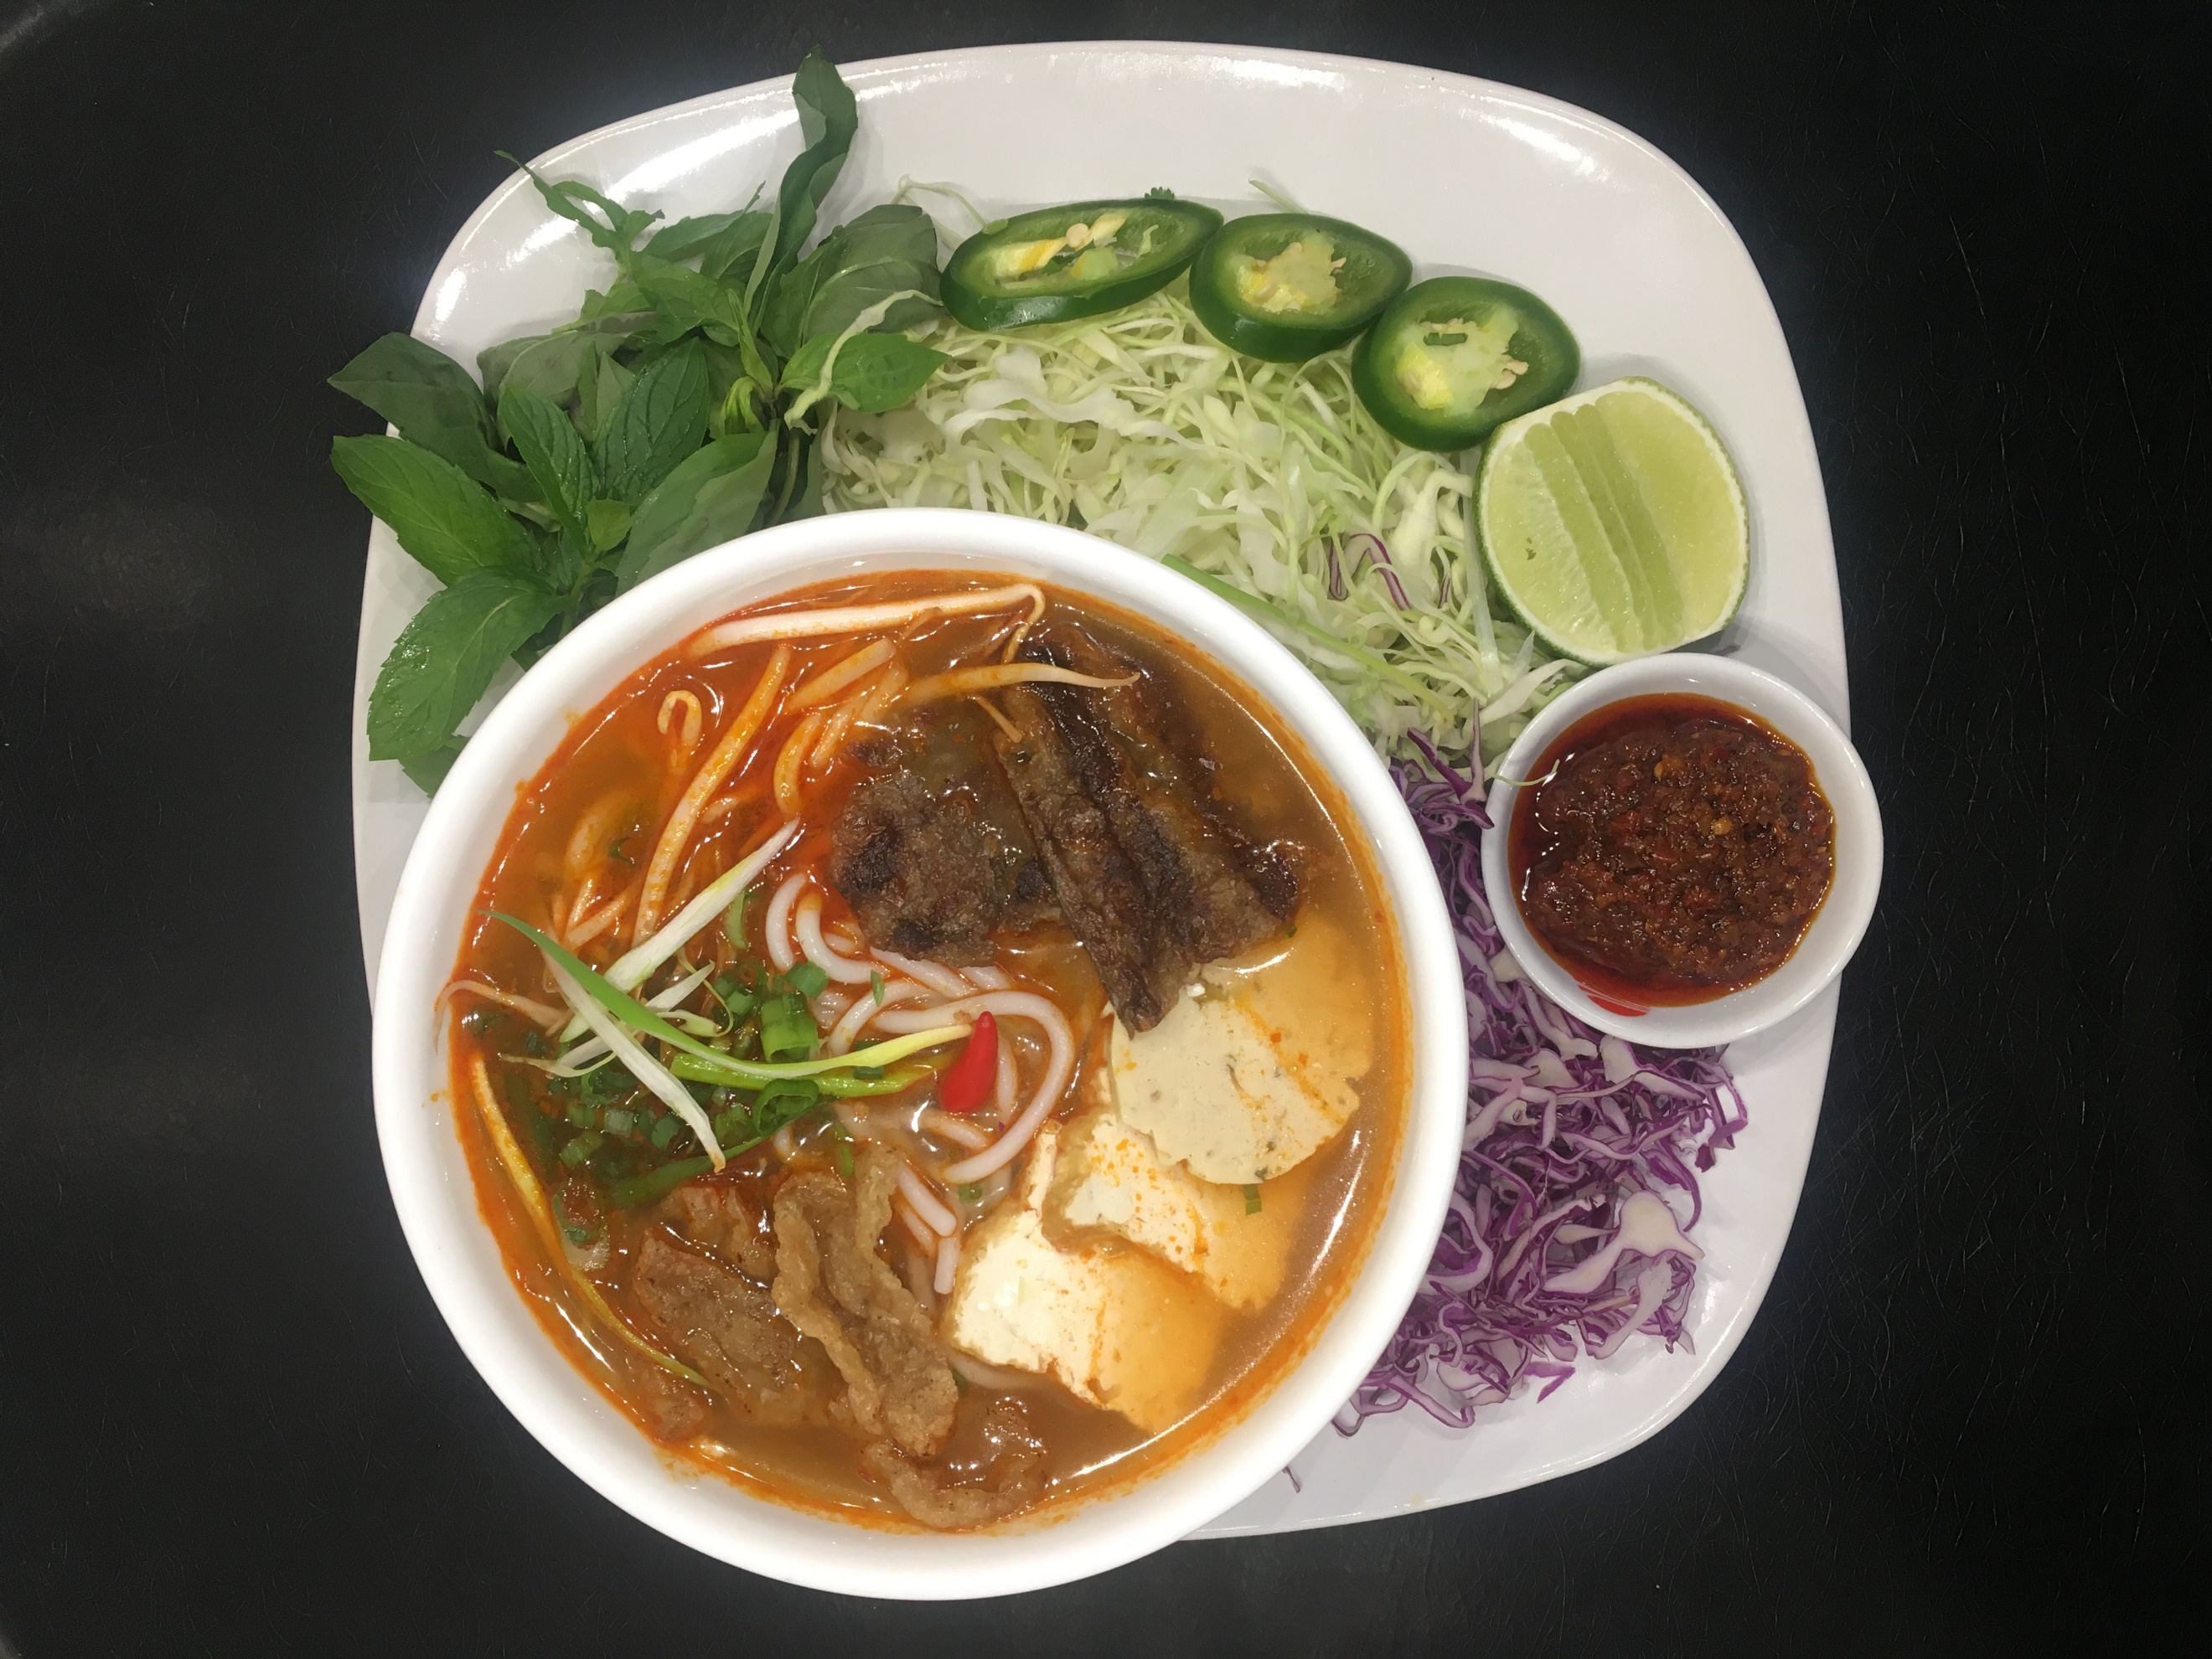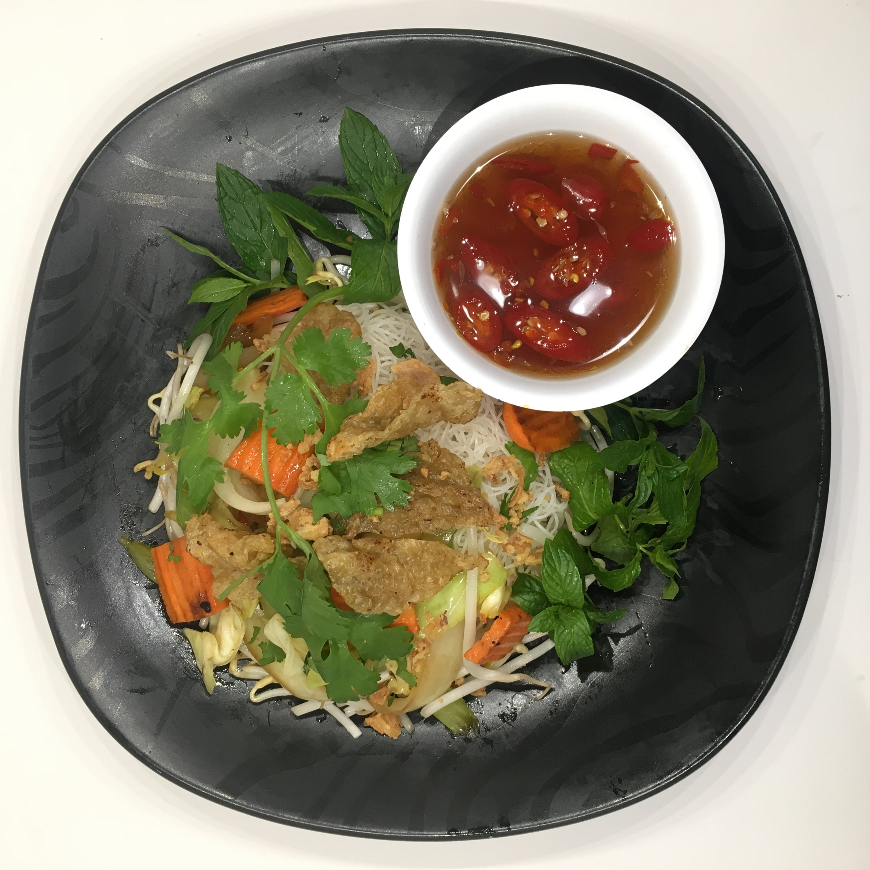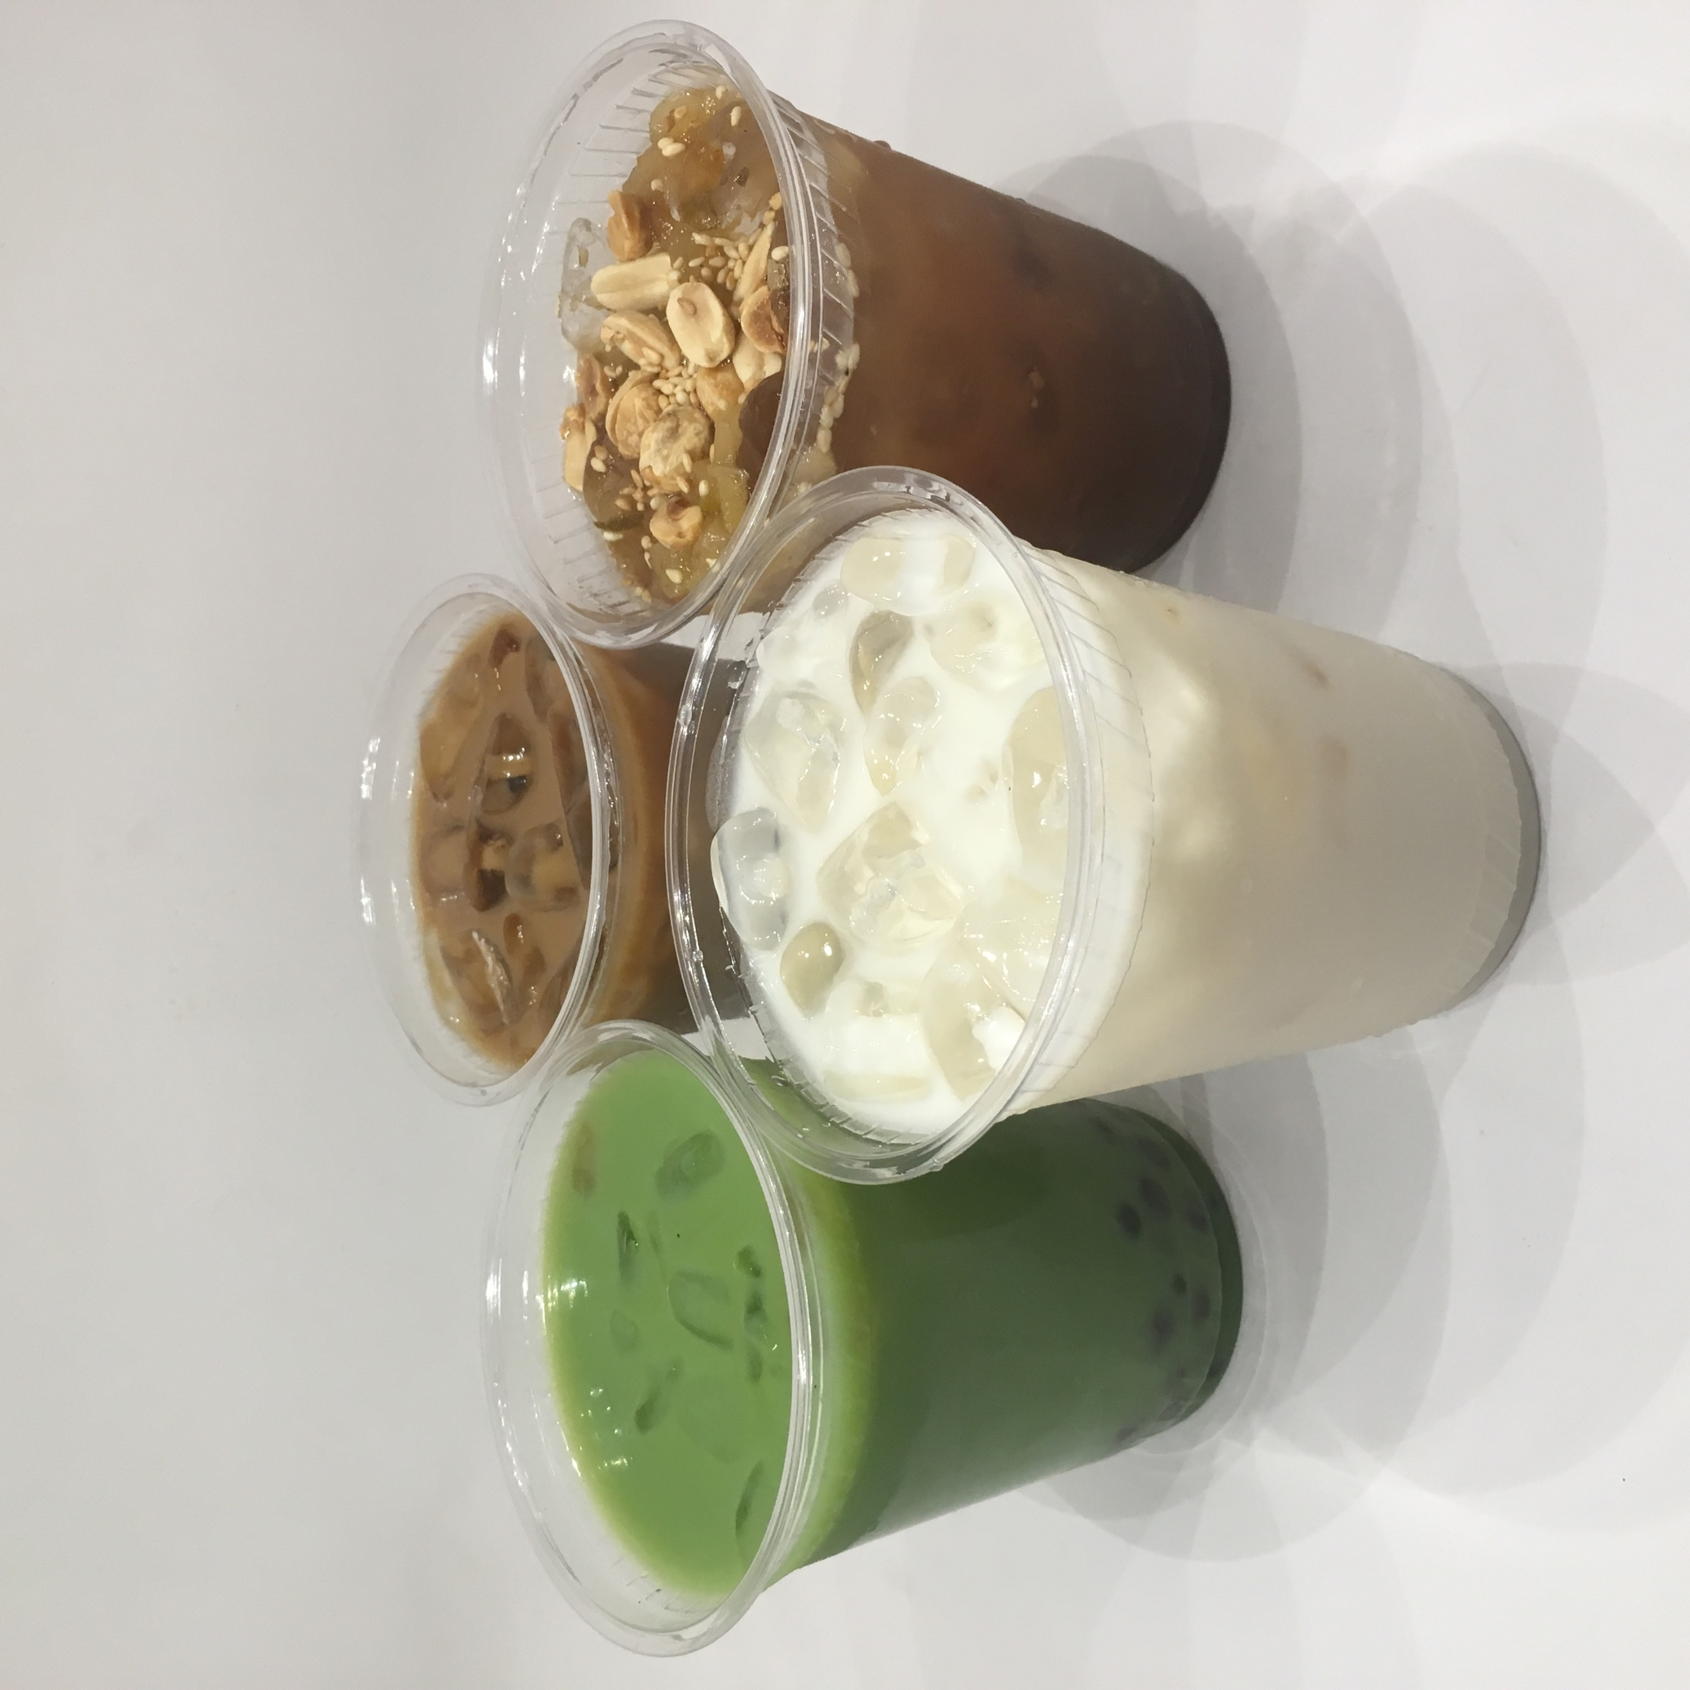

Appetizers

•#A1 (Vegan Fresh Spring Rolls – Gỏi Cuốn) **$1**

•#A2 (Vegan Vietnamese Dumpling) **2 for $1**

•#A3 (Vegan Golden Fried Rolls – Chả Giò) **3 for $2**

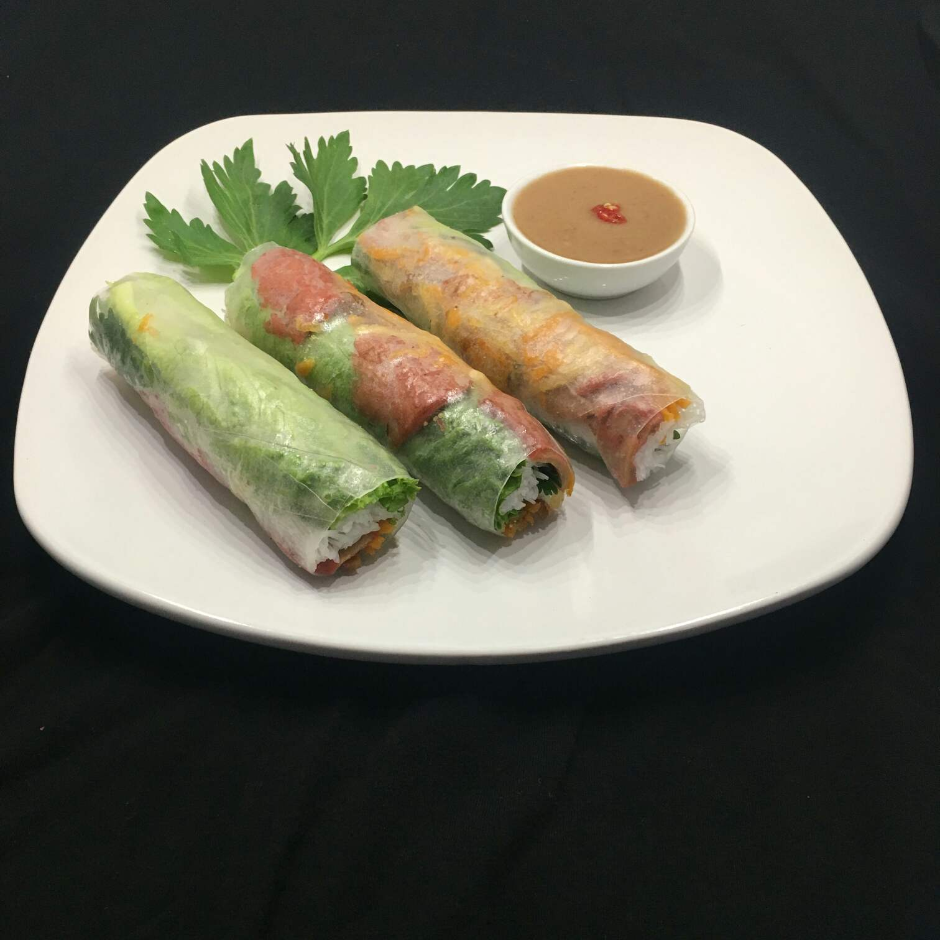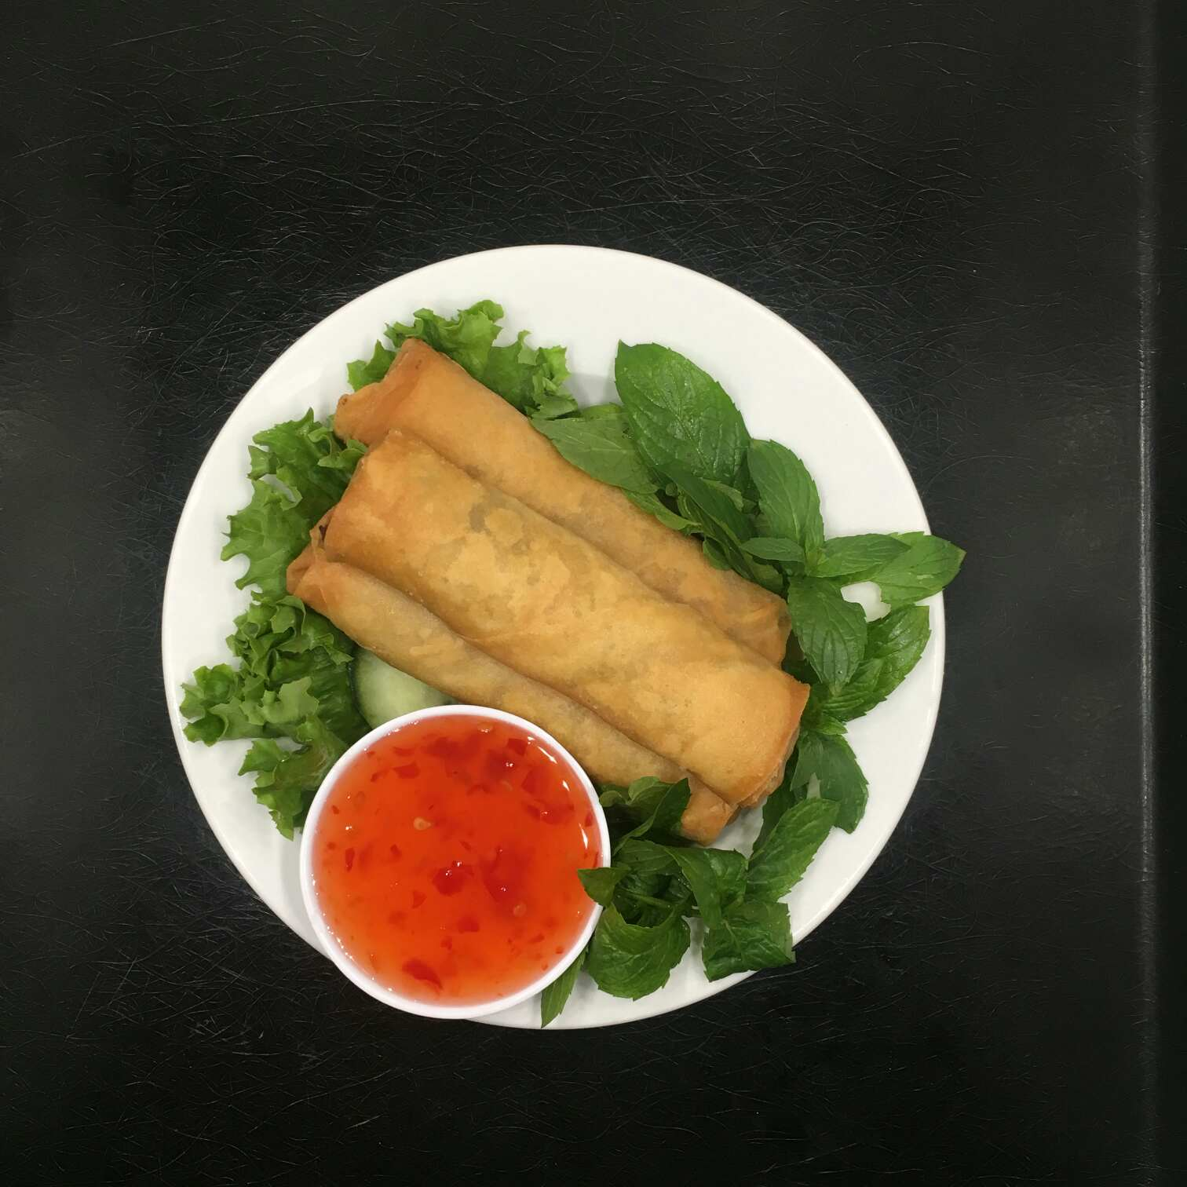

Bánh Mì (Viet Baguette)

*Shredded fried potato, carrot, cilantro, cucumber, jalapeño,*

*and pickle carrot*

•#BM1 (Vegan Savory BBQ – Thịt Nướng)

•#BM2 (Vegan Braised Tofu - Đậu Hủ Sả Ớt)

•#BM3 (Vegan Spicy Lemon Grass Protein-Mì Căn Sả Ớt)

•#Bun4 (Vegan Steamed Bun - Bánh Bao)

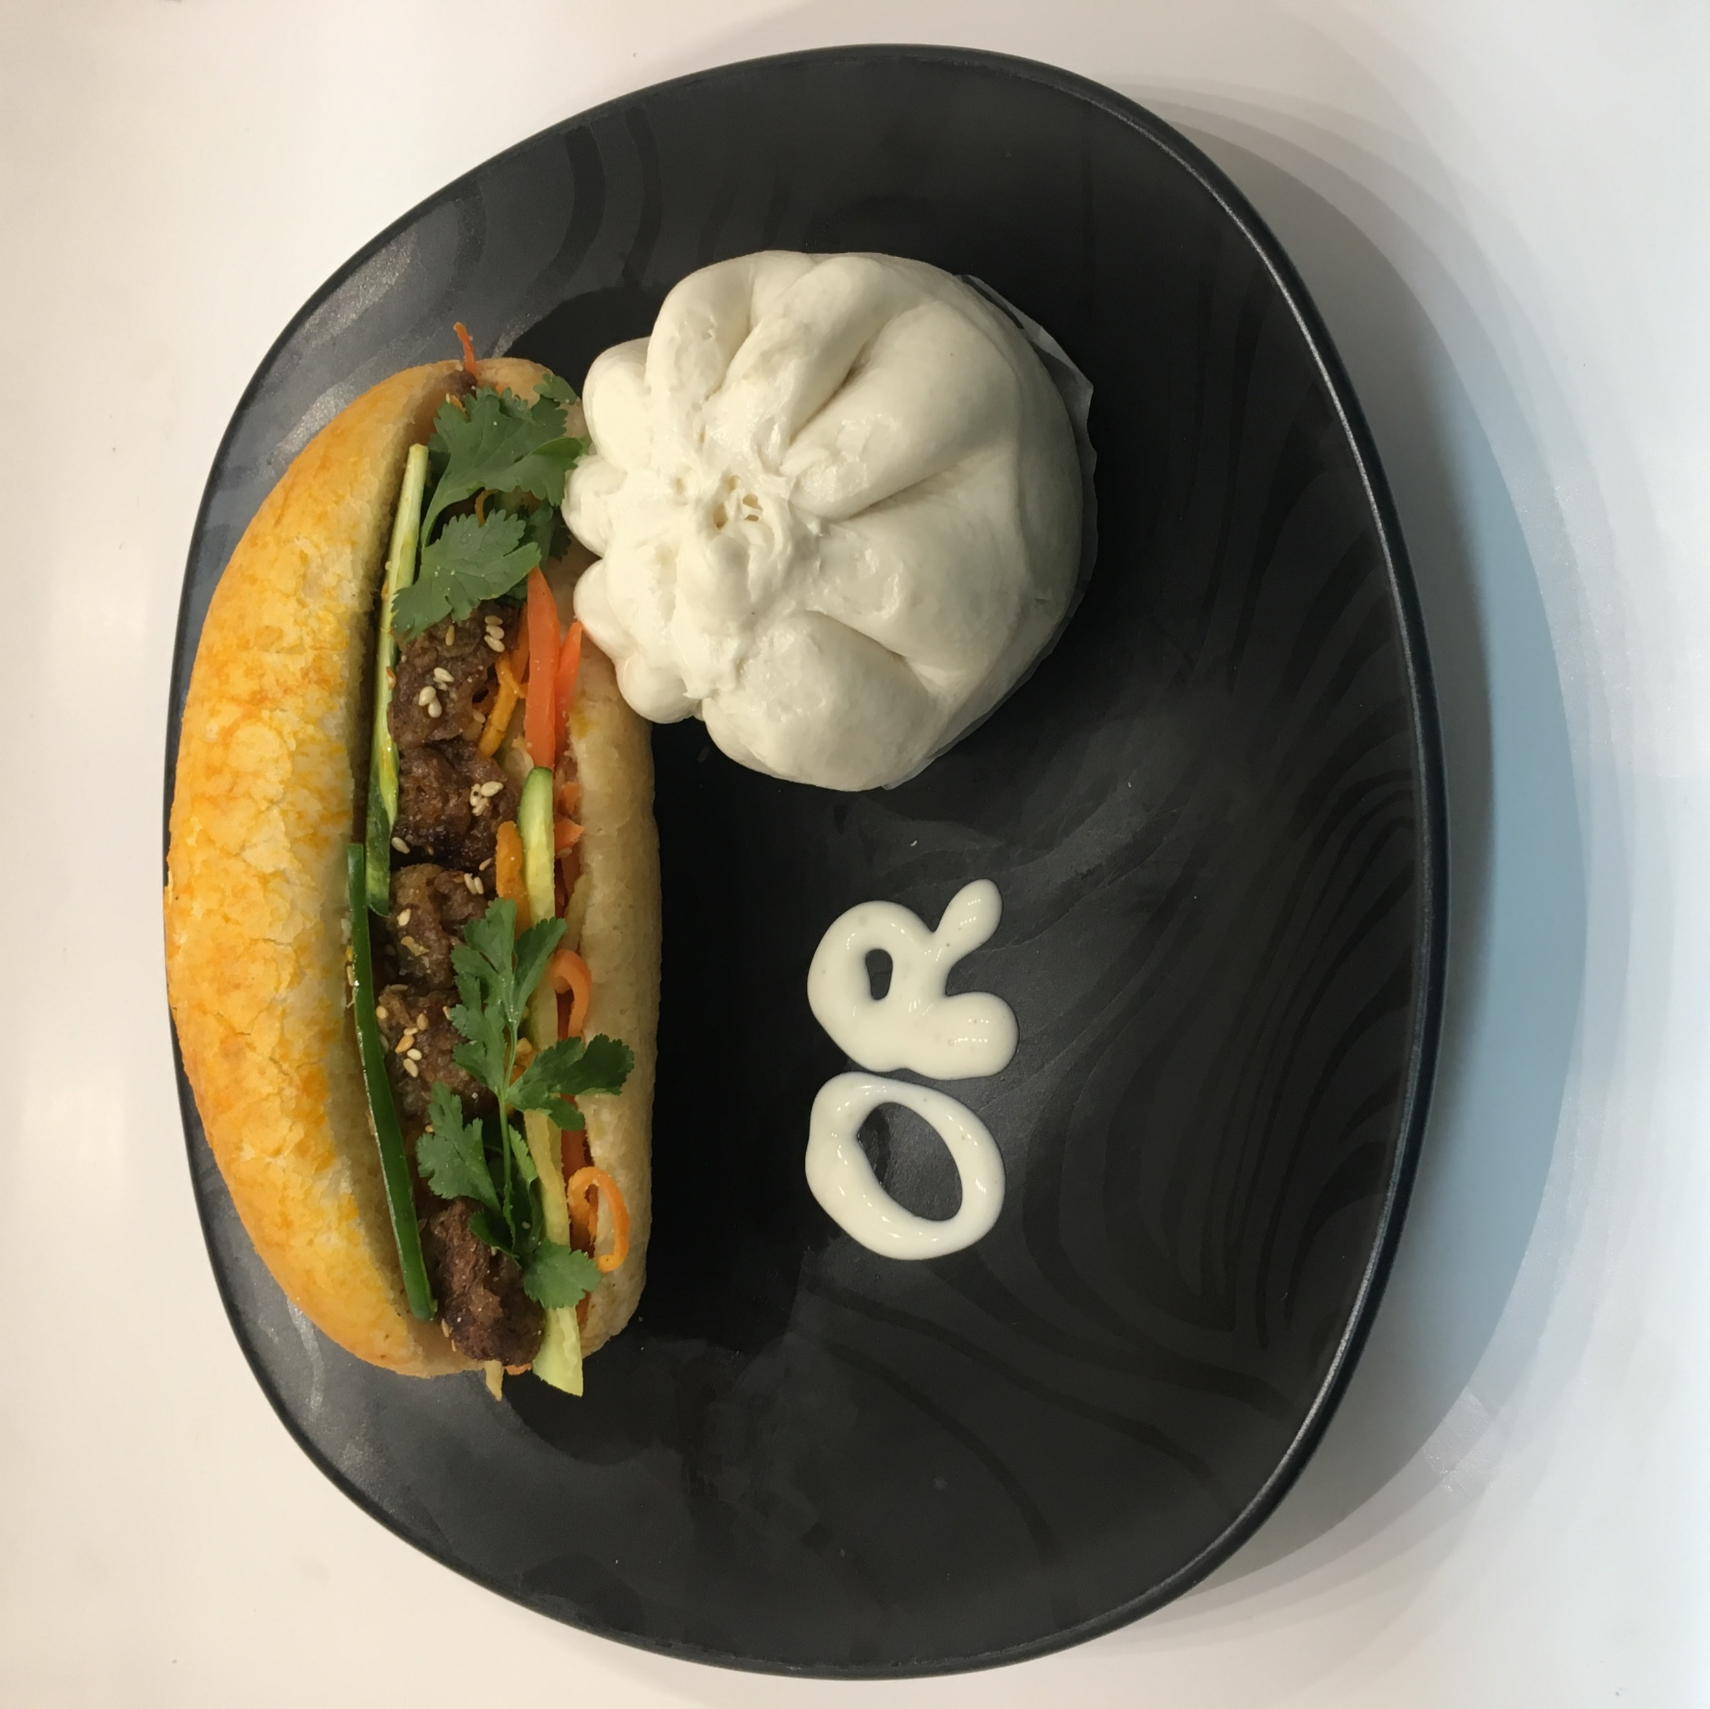

*Salad, cucumber, mint, jalapeño, pickled carrot, green onion,*

*and golden fried roll*

•#V1 (Vegan Savory BBQ - Bún Thịt Nướng)

•#V2 (Vegan Hanoi Grilled Protein - Bún Chả Hà Nội)

•#V3 (Vegan Shredded Vegetable w/ Coconut Milk - Bún Tằm Bì)

•#V4 (Vegan Fermented Mixed Vegetable-Bún Mắm Thái)

Vermicelli Plates **$6**

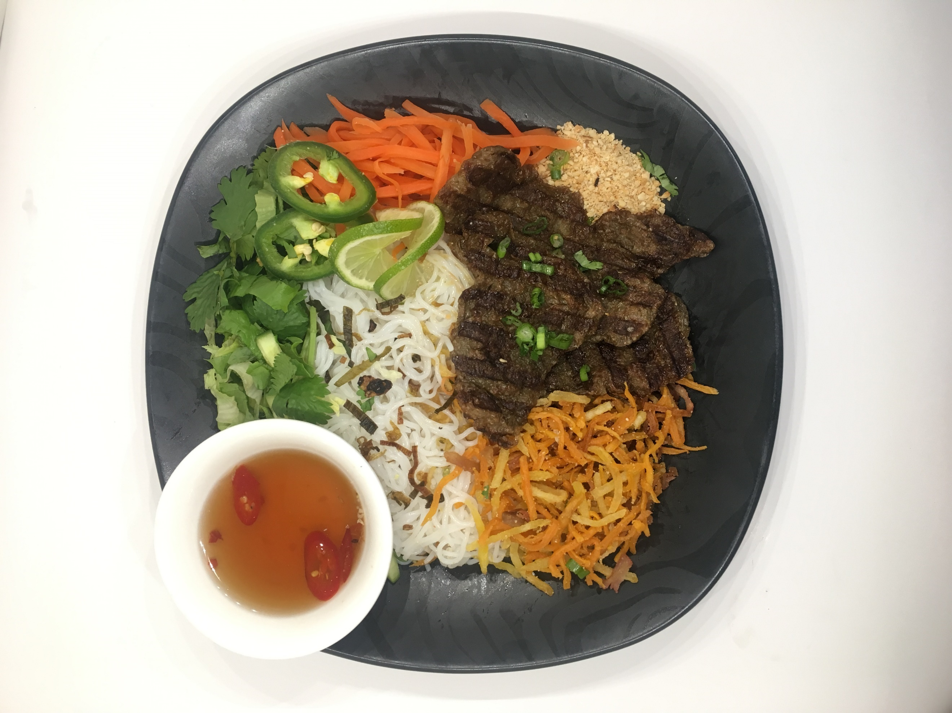

Rice Plates **$6**

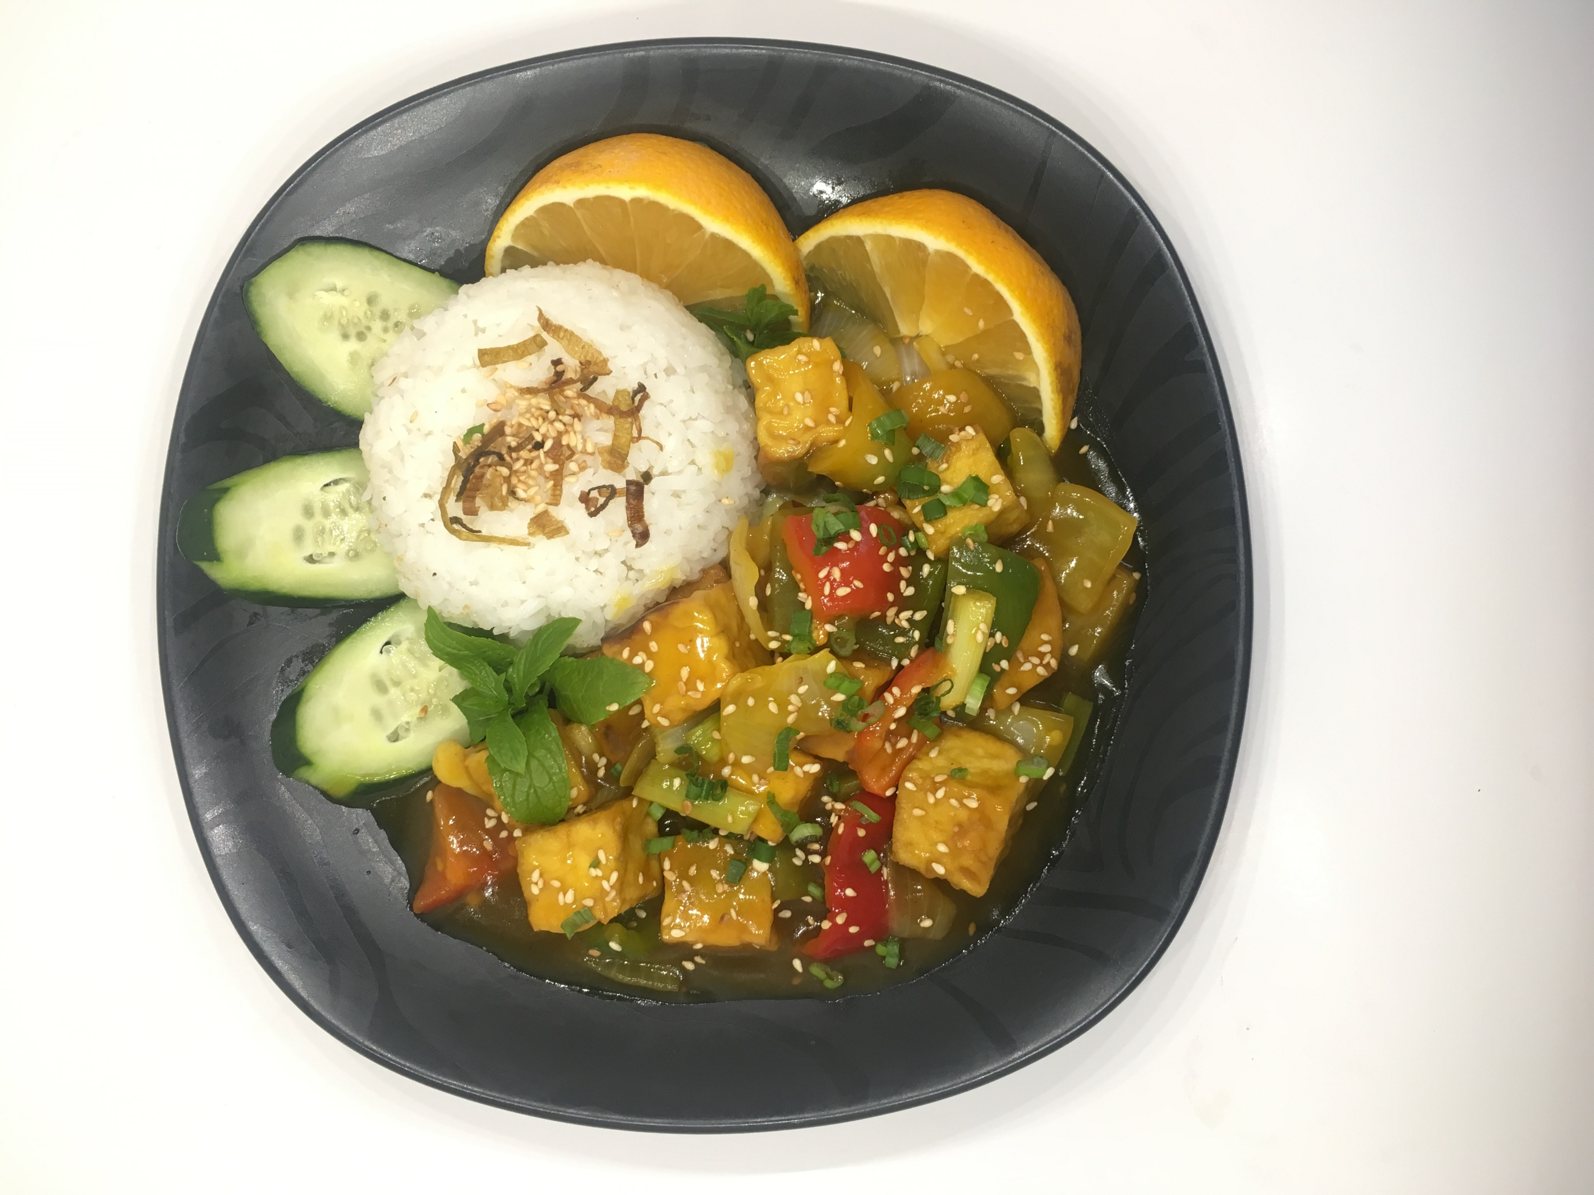

*Cucumber, tomatoes, lettuce, pickled carrot, green onion, jalapeño, and/or steamed vegetables*

•#R1 (Vegan/Vegetarian Broken Rice - Cơm Tấm Bì)

•#R2 (Vegan/Vegetarian Fried Rice – [Cơm Chiên](https://www.google.com/search?client=safari&rls=en&q=vietnamese+to+english&ie=UTF-8&oe=UTF-8))

•#R3 (Vegan Spicy Pineapple Curry – Cơm Cari Khóm)

#R4 (Vegan Viet Shaking Beef-less – Cơm Bò Lúc Lắc)

#R5 (Vegan Braised Jackfruit – Cơm Mít Kho Tộ)

#R6 (Vegan Orange Tofu – Cơm Đậu Hủ Sốt Cam)

#R7 (Vegan Spicy Lemongrass Tofu – Cơm Đậu Hủ Xả Ớt)

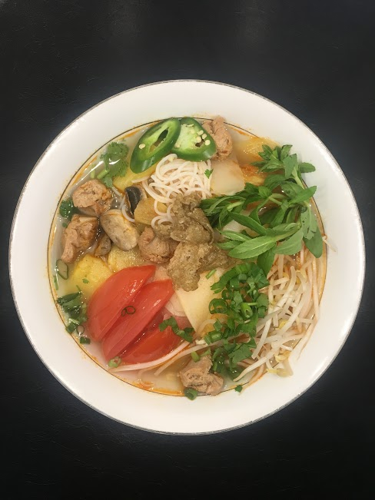

**$2**

**$3**

Desserts & Drinks

**$3**

•#D1 (Vegan Silky Tofu w/ Ginger Syrup + Cocunut Milk - Đậu Hủ Nước Đường)

#D2 (Vegan Steamed Banana w/ Coconut Milk – Bánh Chuối Hấp)

#D3 (Vegan Coconut Taro Rice Pudding –

Chè Khoai Môn)

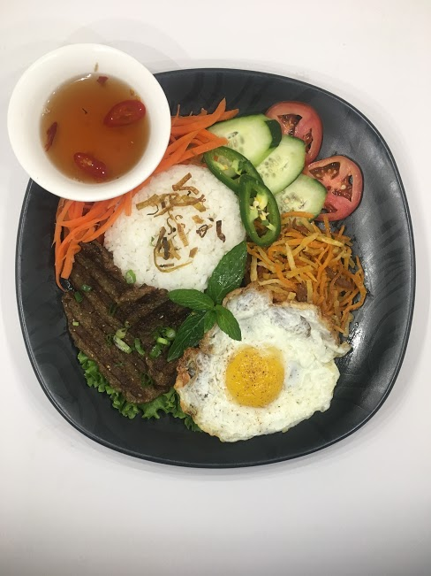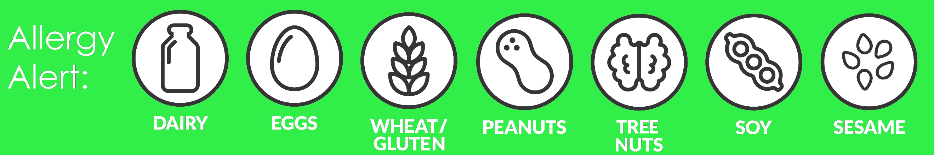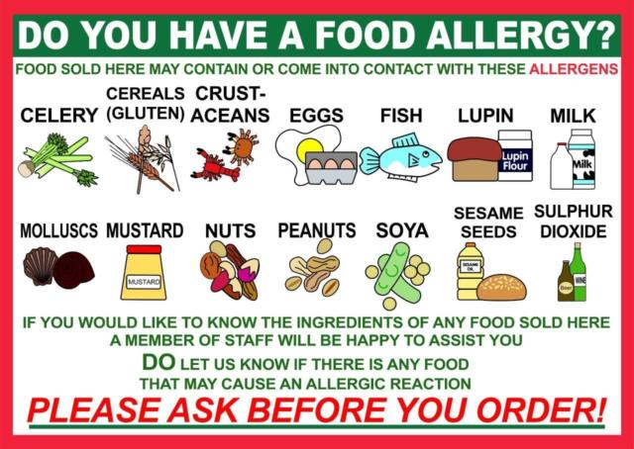

Tax is included in prices!

Accept Debit/Credit Card for $5 and Up

*Menu Key*

⏺Daily

🗖 Every Other Week

**$1**

**$3**

**$2**

MENU KEY

⏺Daily

Every Other Week

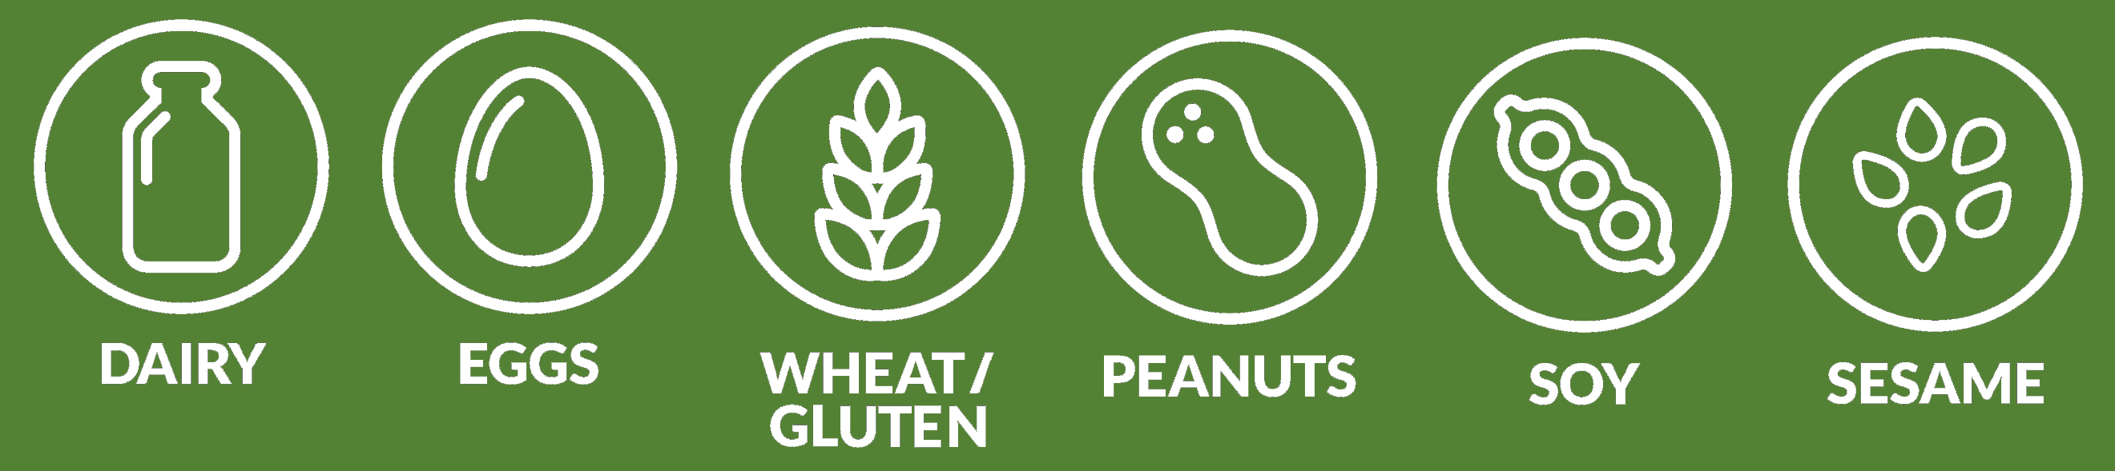

TAX IS INCLUDED IN PRICE!

Accept Debit/Credit Card for $5 and Up